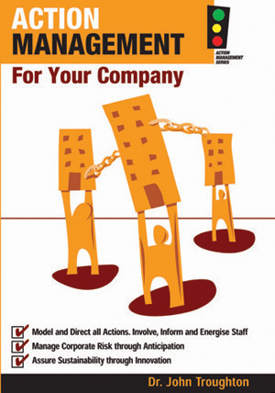  Providing clients with  Secure Data Hosting  with 24/7 access to AMS applications | 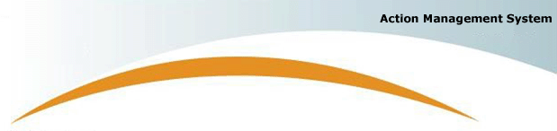

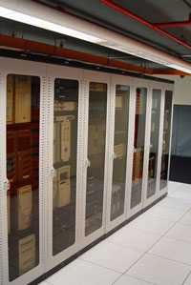  ^^^^^^^^^^  State-of-the-Art  Secure AMS Hosting  What do our  Clients think?  “The AMS system has really helped my business improve the way our staff works together. The Job 5x5 approach is including all staff in the way our business does things and with the Business DNA they can see the big picture and how our business relies on them and other staff. The direct availability of business knowledge is breaking down communication walls so we all do things the same way.”  John Paine  Managing Director  Danaher’s Timber  and Hardware.    133 Alexander Street  Crows Nest NSW 2065  Australia  Phone: 61-(0)2-9431 5305  Fax: 61-(0)2-9439 2738 | Providing business with 24/7 operational access  - Redundant hardware configurations with one-site replacement.  - Unique Domain names created for all clients (e.g. www.nia.amshost.biz).  - Real-time RAID disk array for mirrored transaction processing.  - 2nd Level Disk back-up PLUS daily 3rd Level Network Server back-up.  The Action Management System increases understanding of the business by all staff & creates a platform for success  Email us at: ask@themanagementpractice.com  Find out more at: www.actionmanagement.com.au
  - Real-time back-up of all client transactions
  - 3-Level back-up of all AMS and client data
  - SSL 128-bit encryption of AMS transactions
  - Multi homed network connectivity  - 100Mbps Ethernet link to PowerTel, 40Mbps link to MCI  - Core network equipment is redundant  - UPS system in place to provide clean reliable power  - Dry head hydrants for fire protection | Secure Hosting of AMS  in Australian facility  The Management Practice (TMP) hosts their AMS Internet Application Servers at Anchor Systems Pty Ltd in Sydney Australia. Both TMP and Anchor are entirely Australian based companies. All equipment and infrastructure used to support the hosting services is securely located in the Anchor data centre in the Sydney CBD with immediate and 24 x 7 access.  All servers are high-end rack-mount equipment with a large onsite inventory of spare components and identical servers to allow rapid resolution of faults and  a 99.8% uptime guarantee. | - Dual onsite Diesel generator is used to supply power for extended outages  - Onsite security guards 24 x 7  - Back to base alarm system  - Electronic access control systems  - 24 x 7 access to allow out of hours fault resolution  - Servers are monitored continuously, 24x7
  - Simple and fast to Implement.  - Fixed low-cost implementation in two  half-day workshops over 48 hours.  - Reduces business complexity  - Produces a simple “one-page” graphical view of the entire business operation  - Creates transparency to all stakeholders  - Produces a simple platform and logical framework for the business strategy | - Clarifies accountability and aligns both staff and management expectation  - Creates a common understanding of the business for all employees  - Encourages immediate pro-active staff interaction with management  - Creates pro-active contribution by everyone  - Identifies the most appropriate pathway for optimal improvements to the business

